Business Unit
Mobile Failures Report
ASAP 7.0.2 – JAMU66

Week 33
August 13th to August 19th, 2018

August 20th, 2018

Contents

1 Percentages for all mobile activations, changes and deactivations Anguilla 4
2 Percentages for all mobile activations, changes and deactivations Antigua 5
3 Percentages for all mobile activations, changes and deactivations Barbados 6
4 Percentages for all mobile activations, changes and deactivations British Virgin Islands 7
5 Percentages for all mobile activations, changes and deactivations Cayman 8
6 Percentages for all mobile activations, changes and deactivations Dominica 9
7 Percentages for all mobile activations, changes and deactivations Grenada 10
8 Percentages for all mobile activations, changes and deactivations Jamaica 11
9 Percentages for all mobile activations, changes and deactivations Monserrat 12
10 Percentages for all mobile activations, changes and deactivations Saint Vincent 13
11 Percentages for all mobile activations, changes and deactivations Turks and Caicos 14
12 Percentages for all mobile activations, changes and deactivations Santa Lucia 15
13 Percentages for all mobile activations, changes and deactivations Saint Kitts and Nevis 16
14 Top 5 failure issues Anguilla 17
15 Top 5 failure issues Antigua 17
16 Top 5 failure issues Barbados 17
17 Top 5 failure issues British Virgin Islands 19
18 Top 5 failure issues Cayman 19
19 Top 5 failure issues Dominica 19
20 Top 5 failure issues Grenada 19
21 Top 5 failure issues Jamaica 20
22 Top 5 failure issues Monserrat 20
23 Top 5 failure issues Saint Vincent 20
24 Top 5 failure issues Turks and Caicos 20
25 Top 5 failure issues Santa Lucia 21
26 Top 5 failure issues Saint Kitts and Nevis 21
27 Failure numbers Anguilla 21
28 Failure numbers Antigua 21
29 Failure numbers Barbados 23
30 Failure numbers British Virgin Islands 32
31 Failure numbers Cayman 32
32 Failure numbers Dominica 33
33 Failure Numbers Grenada 34
34 Failure numbers Jamaica 34
35 Failure numbers Monserrat 35
36 Failure numbers Saint Vincent 35
37 Failure numbers Turks and Caicos 35
38 Failure numbers Santa Lucia 37
39 Failure numbers Saint Kitts and Nevis 38

Percentages for all mobile activations, changes and deactivations Anguilla

 | TOTAL | COMPLETE | FAILED | % Total | % COMPLETE | % FAILED
ACTIVATE | 58 | 57 | 1 | 15% | 98% | 2%
DEACTIVATE | 98 | 97 | 1 | 25% | 99% | 1%
MODIFY | 244 | 235 | 9 | 61% | 96% | 4%

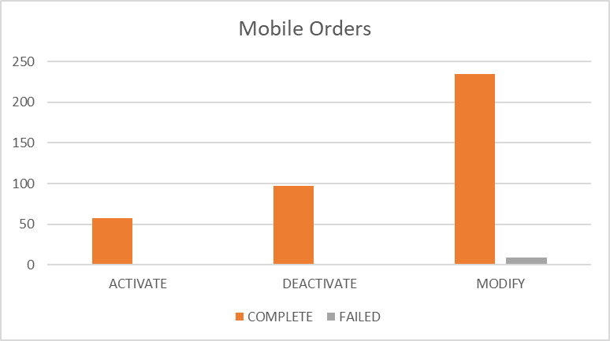

Percentages for all mobile activations, changes and deactivations Antigua

 | TOTAL | COMPLETE | FAILED | % Total | % COMPLETE | % FAILED
ACTIVATE | 562 | 528 | 34 | 26% | 94% | 6%
DEACTIVATE | 277 | 277 | 0 | 13% | 100% | 0%
MODIFY | 1295 | 1238 | 57 | 61% | 96% | 4%

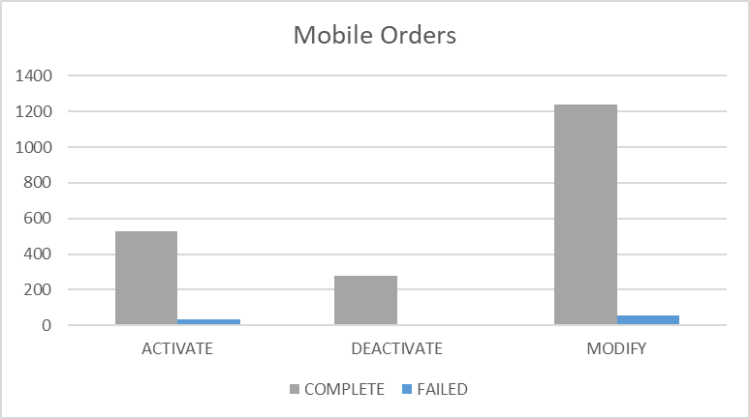

Percentages for all mobile activations, changes and deactivations Barbados

 | TOTAL | COMPLETE | FAILED | % Total | % COMPLETE | % FAILED
ACTIVATE | 7025 | 6695 | 330 | 44% | 95% | 5%
DEACTIVATE | 816 | 816 | 0 | 5% | 100% | 0%
MODIFY | 8288 | 7936 | 352 | 51% | 96% | 4%

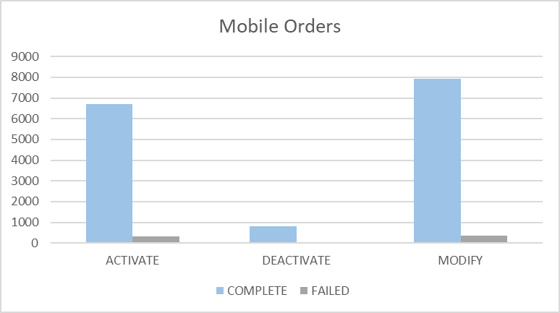

Percentages for all mobile activations, changes and deactivations British Virgin Islands

 | TOTAL | COMPLETE | FAILED | % Total | % COMPLETE | % FAILED
ACTIVATE | 130 | 130 | 0 | 4% | 100% | 0%
DEACTIVATE | 263 | 263 | 0 | 8% | 100% | 0%
MODIFY | 2913 | 2907 | 6 | 88% | 100% | 0%

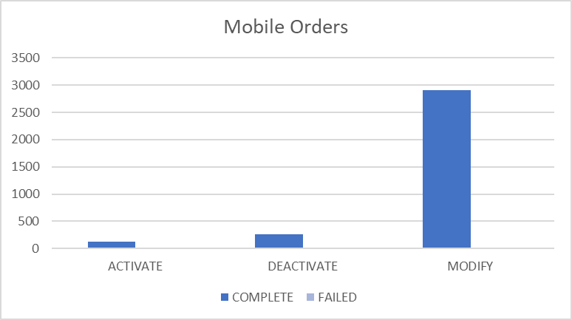

Percentages for all mobile activations, changes and deactivations Cayman

 | TOTAL | COMPLETE | FAILED | % Total | % COMPLETE | % FAILED
ACTIVATE | 56 | 55 | 1 | 4% | 98% | 2%
DEACTIVATE | 288 | 284 | 4 | 21% | 99% | 1%
MODIFY | 1025 | 1006 | 19 | 75% | 98% | 2%
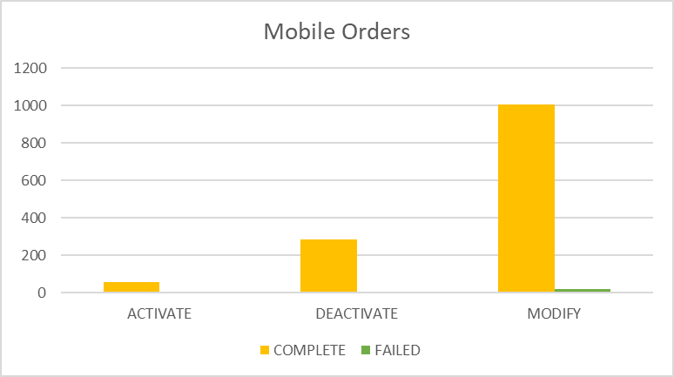

Percentages for all mobile activations, changes and deactivations Dominica

 | TOTAL | COMPLETE | FAILED | % Total | % COMPLETE | % FAILED
ACTIVATE | 182 | 167 | 15 | 12% | 92% | 8%
DEACTIVATE | 403 | 393 | 10 | 26% | 98% | 2%
MODIFY | 949 | 932 | 17 | 62% | 98% | 2%

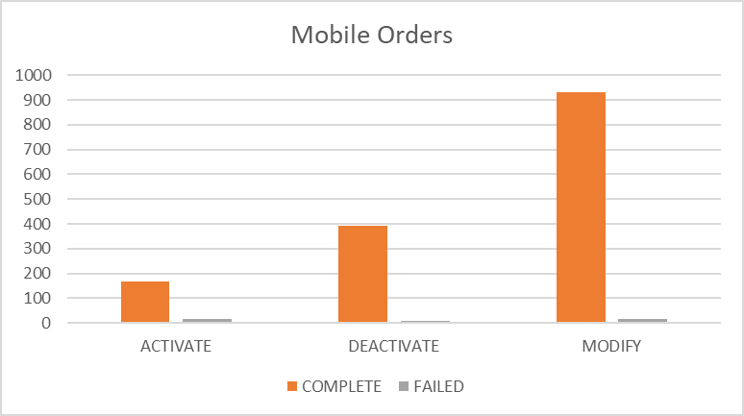

Percentages for all mobile activations, changes and deactivations Grenada

 | TOTAL | COMPLETE | FAILED | % Total | % COMPLETE | % FAILED
ACTIVATE | 81 | 81 | 0 | 7% | 100% | 0%
DEACTIVATE | 447 | 447 | 0 | 36% | 100% | 0%
MODIFY | 718 | 713 | 5 | 58% | 99% | 1%

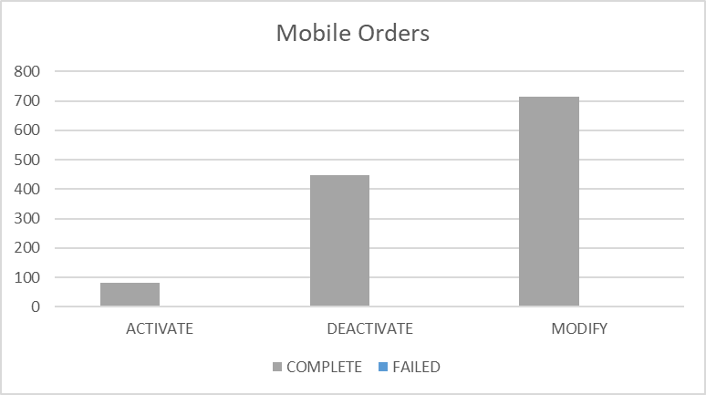

Percentages for all mobile activations, changes and deactivations Jamaica

 | TOTAL | COMPLETE | FAILED | % Total | % COMPLETE | % FAILED
ACTIVATE | 4486 | 4477 | 9 | 16% | 100% | 0%
DEACTIVATE | 5774 | 5774 | 0 | 21% | 100% | 0%
MODIFY | 17576 | 17535 | 41 | 63% | 100% | 0%

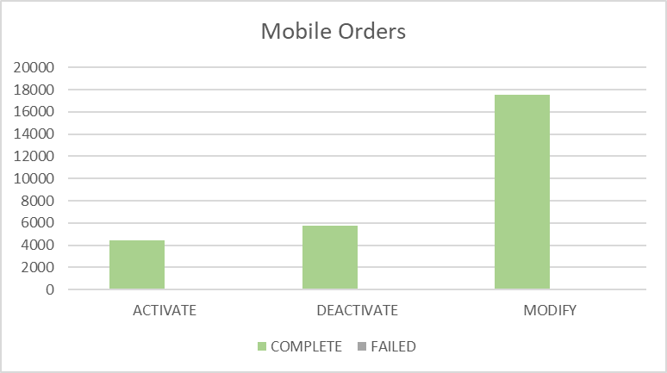

Percentages for all mobile activations, changes and deactivations Monserrat

 | TOTAL | COMPLETE | FAILED | % Total | % COMPLETE | % FAILED
ACTIVATE | 25 | 25 | 0 | 19% | 100% | 0%
DEACTIVATE | 25 | 25 | 0 | 19% | 100% | 0%
MODIFY | 83 | 80 | 3 | 62% | 96% | 4%

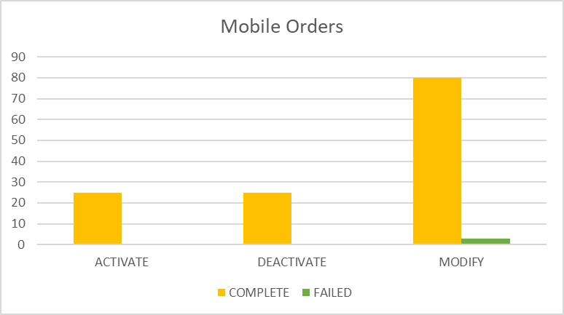

Percentages for all mobile activations, changes and deactivations Saint Vincent

 | TOTAL | COMPLETE | FAILED | % Total | % COMPLETE | % FAILED
ACTIVATE | 538 | 537 | 1 | 19% | 100% | 0%
DEACTIVATE | 732 | 732 | 0 | 26% | 100% | 0%
MODIFY | 1504 | 1501 | 3 | 54% | 100% | 0%

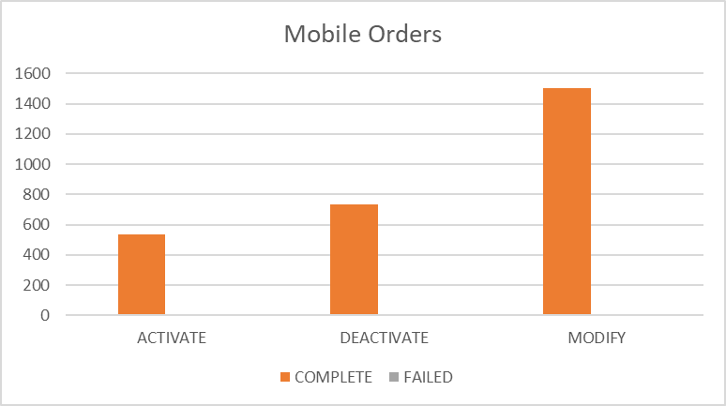

Percentages for all mobile activations, changes and deactivations Turks and Caicos

 | TOTAL | COMPLETE | FAILED | % Total | % COMPLETE | % FAILED
ACTIVATE | 193 | 179 | 14 | 12% | 93% | 7%
DEACTIVATE | 376 | 376 | 0 | 24% | 100% | 0%
MODIFY | 1023 | 945 | 78 | 64% | 92% | 8%

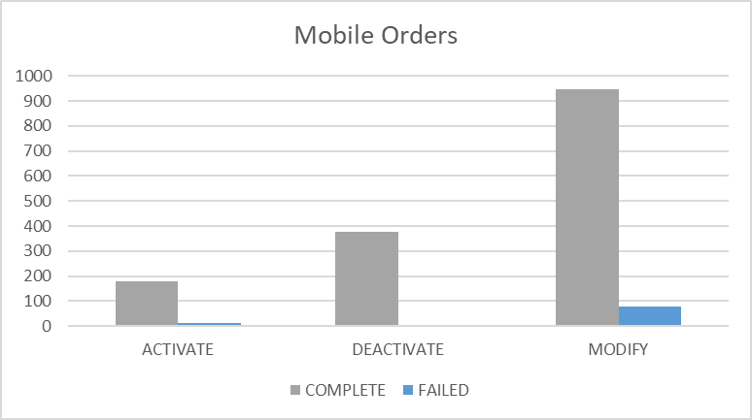

Percentages for all mobile activations, changes and deactivations Santa Lucia

 | TOTAL | COMPLETE | FAILED | % Total | % COMPLETE | % FAILED
ACTIVATE | 636 | 633 | 3 | 20% | 100% | 0%
DEACTIVATE | 662 | 662 | 0 | 21% | 100% | 0%
MODIFY | 1827 | 1818 | 9 | 58% | 100% | 0%

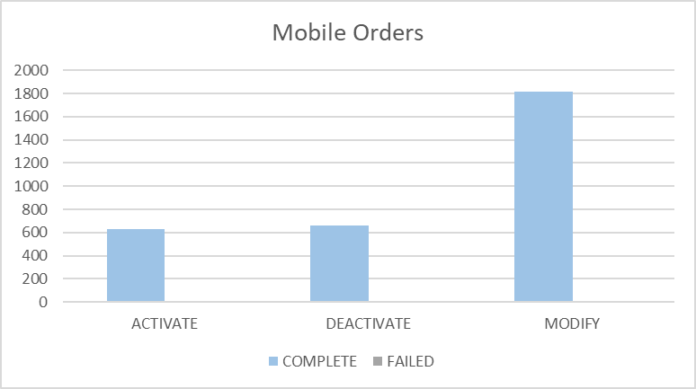

Percentages for all mobile activations, changes and deactivations Saint Kitts and Nevis

 | TOTAL | COMPLETE | FAILED | % Total | % COMPLETE | % FAILED
ACTIVATE | 233 | 227 | 6 | 20% | 97% | 3%
DEACTIVATE | 174 | 174 | 0 | 15% | 100% | 0%
MODIFY | 785 | 776 | 9 | 66% | 99% | 1%

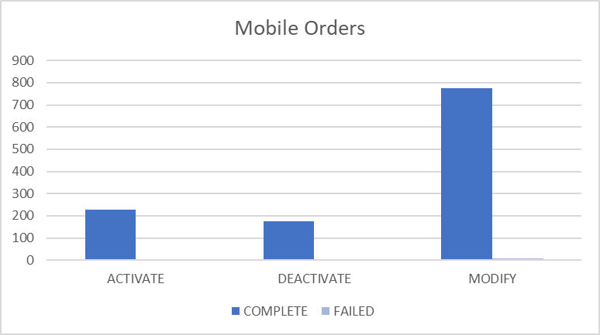

Top 5 failure issues Anguilla

3 | EMA_MISS_REQ_PARAM:Mandatory parameter is missing from work order
2 | EMA_RESP_35101:Missing or invalid parameter.
1 | EMA_RESP_13:The Specified IMSI is not defined
1 | LIME_BBRYNOUDETMATCH:No User Defined Exit Type Found.
1 | EMA_RESP_6:Subscriber authentication data not found
1 | EMA_RESP_2:The Specified MSISDN is already defined with a different IMSI

Top 5 failure issues Antigua

42 | EMA_RESP_35101:Missing or invalid parameter.
7 | EMA_MISS_REQ_PARAM:Mandatory parameter is missing from work order
4 | EMA_RESP_1:The Specified IMSI is already defined
2 | EMA_RESP_14:The Specified MSISDN is not defined
1 | EMA_RESP_2:The Specified MSISDN is already defined with a different IMSI
1 | EMA_RESP_13:The Specified IMSI is not defined

Top 5 failure issues Barbados

302 | EMA_RESP_2:The Specified MSISDN is already defined with a different IMSI
25 | EMA_RESP_35101:Missing or invalid parameter.
5 | NGVM_ETTY_DSNT_EXST:The specified Mailbox ID does not exist on the Comverse Voicemail platform.
4 | FAIL:No such object
3 | SAPC_PROVCARTEXP:The NE was denid due to provisioning cartridge exception
3 | EMA_RESP_14:The Specified MSISDN is not defined
2 | EMA_RESP_41:BSG not subscribed
2 | EMA_RESP_1001:External system communication link failure.
2 | EMA_RESP_61:SS not applicable to any subscribed BSG
1 | EMA_MISS_REQ_PARAM:Mandatory parameter is missing from work order
1 | FAIL:Invalid syntax
1 | EMA_RESP_35105:The subscriber already exists.
1 | EMA_RESP_1:The Specified IMSI is already defined

Top 5 failure issues British Virgin Islands

3 | FAIL:No such object
1 | EMA_RESP_13:The Specified IMSI is not defined
1 | EMA_RESP_1001:External system communication link failure.
1 | EMA_RESP_2:The Specified MSISDN is already defined with a different IMSI

Top 5 failure issues Cayman

11 | EMA_RESP_35106:The subscriber does not exist.
4 | MMS10_NO_UDET_MATCH:No User Defined Exit Type Found
1 | NGVM_ETTY_DSNT_EXST:The specified Mailbox ID does not exist on the Comverse Voicemail platform.
1 | EMA_RESP_35101:Missing or invalid parameter.
1 | EMA_RESP_1:The Specified IMSI is already defined
1 | SAPC_PROVCARTEXP:The NE was denid due to provisioning cartridge exception

Top 5 failure issues Dominica

7 | EMA_RESP_35101:Missing or invalid parameter.
5 | EMA_RESP_6:Subscriber authentication data not found
4 | NGVM_ETTY_DSNT_EXST:The specified Mailbox ID does not exist on the Comverse Voicemail platform.
1 | SAPC_PROVCARTEXP:The NE was denid due to provisioning cartridge exception

Top 5 failure issues Grenada

4 | EMA_RESP_1:The Specified IMSI is already defined
1 | NGVM_ETTY_DSNT_EXST:The specified Mailbox ID does not exist on the Comverse Voicemail platform.

Top 5 failure issues Jamaica

14 | NGVM_ETTY_DSNT_EXST:The specified Mailbox ID does not exist on the Comverse Voicemail platform.
5 | EMA_RESP_35101:Missing or invalid parameter.
5 | SAPC_EXCEPTION:The NE was denid due to general exception
4 | EMA_RESP_1:The Specified IMSI is already defined
2 | EMA_RESP_14:The Specified MSISDN is not defined
2 | EMA_RESP_1001:External system communication link failure.
2 | FAIL:No such object

Top 5 failure issues Monserrat

2 | NGVM_ETTY_DSNT_EXST:The specified Mailbox ID does not exist on the Comverse Voicemail platform.
1 | FAIL:No such object

Top 5 failure issues Saint Vincent

2 | EMA_RESP_3005:Invalid Argument or out of Range
1 | EMA_RESP_2:The Specified MSISDN is already defined with a different IMSI

Top 5 failure issues Turks and Caicos

44 | EMA_RESP_35106:The subscriber does not exist.
18 | EMA_RESP_35101:Missing or invalid parameter.
13 | EMA_RESP_1:The Specified IMSI is already defined
1 | EMA_RESP_13:The Specified IMSI is not defined
1 | FAIL:No such object
1 | EMA_RESP_35105:The subscriber already exists.

Top 5 failure issues Santa Lucia

3 | NGVM_ETTY_DSNT_EXST:The specified Mailbox ID does not exist on the Comverse Voicemail platform.
2 | FAIL:Invalid syntax
2 | FAIL:No such object
1 | EMA_MISS_REQ_PARAM:Mandatory parameter is missing from work order
1 | EMA_RESP_1001:External system communication link failure.

Top 5 failure issues Saint Kitts and Nevis

6 | EMA_RESP_35105:The subscriber already exists.
1 | FAIL:No such object
1 | EMA_MISS_REQ_PARAM:Mandatory parameter is missing from work order
1 | EMA_RESP_35106:The subscriber does not exist.

Failure numbers Anguilla

SRQ_ID | WO_ID | WO_STATUS | MSISDN
985691 | CIS:BAR:1135364:172.21.64.11:25010:1534179255657 | FAILED | 12647292958
994595 | CIS:BAR:1135551:172.21.64.11:25010:1534261549031 | FAILED | 12647720806
996716 | CIS:BAR:1135577:172.21.64.11:25010:1534272456329 | FAILED | 12647290516
1017550 | CIS:BAR:1135885:172.21.64.11:25010:1534401161251 | FAILED | 12647290094
1020591 | CIS:BAR:1136060:172.21.64.11:25010:1534428301218 | FAILED | 12644764537
1020619 | CIS:BAR:1136064:172.21.64.11:25010:1534428521719 | FAILED | 12647720070
1020706 | CIS:BAR:1136071:172.21.64.11:25010:1534428922325 | FAILED | 12644766112
1023853 | CIS:BAR:1136111:172.21.64.11:25010:1534441380538 | FAILED | 12644761007
1031596 | CIS:BAR:1136433:172.21.64.11:25010:1534528661852 | FAILED | 12647721997

Failure numbers Antigua
SRQ_ID | WO_ID | WO_STATUS | MSISDN
984021 | CIS:BAR:2995073:172.21.64.6:25009:1534162277962 | FAILED | 12687829551
984801 | CIS:BAR:2995615:172.21.64.6:25009:1534172821512 | FAILED | 12687892536
984805 | CIS:BAR:2995617:172.21.64.6:25009:1534172838222 | FAILED | 12687892536
985043 | CIS:BAR:2995651:172.21.64.6:25009:1534174822051 | FAILED | 12687728767
985321 | CIS:BAR:2995688:172.21.64.6:25009:1534177075772 | FAILED | 12687714683
986531 | CIS:BAR:2995787:172.21.64.6:25009:1534184518827 | FAILED | 12684644855
986548 | CIS:BAR:2995792:172.21.64.6:25009:1534184629714 | FAILED | 12684644855
993674 | CIS:BAR:2996216:172.21.64.6:25009:1534255920353 | FAILED | 12687761984
994507 | CIS:BAR:2996267:172.21.64.6:25009:1534261115762 | FAILED | 12684641440
995295 | CIS:BAR:2996422:172.21.64.6:25009:1534265296331 | FAILED | 12687282401
996562 | CIS:BAR:2996494:172.21.64.6:25009:1534271693941 | FAILED | 12684643242
996564 | CIS:BAR:2996498:172.21.64.6:25009:1534271695801 | FAILED | 12684643322
996592 | CIS:BAR:2996511:172.21.64.6:25009:1534271872303 | FAILED | 12684643322
996593 | CIS:BAR:2996514:172.21.64.6:25009:1534271876284 | FAILED | 12684643242
996830 | CIS:BAR:2996541:172.21.64.6:25009:1534273270369 | FAILED | 12684641200
997214 | CIS:BAR:2996600:172.21.64.6:25009:1534276367571 | FAILED | 12687235708
1001031 | CIS:BAR:2996802:172.21.64.6:25009:1534307745288 | FAILED | 12687230817
1001305 | CIS:BAR:2997324:172.21.64.6:25009:1534308553352 | FAILED | 12687280265
1001753 | CIS:BAR:2998152:172.21.64.6:25009:1534309947794 | FAILED | 12687706541
1001814 | CIS:BAR:2998332:172.21.64.6:25009:1534310244476 | FAILED | 12687709052
1001853 | CIS:BAR:2998452:172.21.64.6:25009:1534310455600 | FAILED | 12687712545
1001874 | CIS:BAR:2998506:172.21.64.6:25009:1534310563759 | FAILED | 12687714176
1001880 | CIS:BAR:2998530:172.21.64.6:25009:1534310594986 | FAILED | 12687714455
1001918 | CIS:BAR:2998644:172.21.64.6:25009:1534310783608 | FAILED | 12687720221
1001938 | CIS:BAR:2998698:172.21.64.6:25009:1534310883908 | FAILED | 12687722169
1001949 | CIS:BAR:2998734:172.21.64.6:25009:1534310929826 | FAILED | 12687723150
1001951 | CIS:BAR:2998740:172.21.64.6:25009:1534310938410 | FAILED | 12687723507
1001962 | CIS:BAR:2998770:172.21.64.6:25009:1534310999667 | FAILED | 12687723916
1001987 | CIS:BAR:2998830:172.21.64.6:25009:1534311110458 | FAILED | 12687725595
1002005 | CIS:BAR:2998860:172.21.64.6:25009:1534311219099 | FAILED | 12687727313
1002008 | CIS:BAR:2998872:172.21.64.6:25009:1534311228471 | FAILED | 12687728216
1002015 | CIS:BAR:2998896:172.21.64.6:25009:1534311256284 | FAILED | 12687728664
1002028 | CIS:BAR:2998932:172.21.64.6:25009:1534311322314 | FAILED | 12687760859
1002309 | CIS:BAR:2999496:172.21.64.6:25009:1534312800763 | FAILED | 12687724318
1006676 | CIS:BAR:2999686:172.21.64.6:25009:1534334550659 | FAILED | 12687705816
1008411 | CIS:BAR:2999814:172.21.64.6:25009:1534349980285 | FAILED | 12687714455
1009717 | CIS:BAR:2999876:172.21.64.6:25009:1534359386698 | FAILED | 12687706689
1009976 | CIS:BAR:2999922:172.21.64.6:25009:1534362271011 | FAILED | 12687288817
1010043 | CIS:BAR:2999927:172.21.64.6:25009:1534362918631 | FAILED | 12684644251
1010623 | CIS:BAR:3000013:172.21.64.6:25009:1534366946905 | FAILED | 12687641126
1020300 | CIS:BAR:3000247:172.21.64.6:25009:1534424173570 | FAILED | 12687280031
1020308 | CIS:BAR:3000253:172.21.64.6:25009:1534424399553 | FAILED | 12687280031
1021081 | CIS:BAR:3000367:172.21.64.6:25009:1534431423710 | FAILED | 12687285192
1029478 | CIS:BAR:3000658:172.21.64.6:25009:1534510637345 | FAILED | 12687702513
1029770 | CIS:BAR:3000686:172.21.64.6:25009:1534514947465 | FAILED | 12687645607
1029813 | CIS:BAR:3000691:172.21.64.6:25009:1534515397610 | FAILED | 12687230424
1030077 | CIS:BAR:3000703:172.21.64.6:25009:1534517873809 | FAILED | 12687230424
1030092 | CIS:BAR:3000704:172.21.64.6:25009:1534518032498 | FAILED | 12687230424
1031605 | CIS:BAR:3000788:172.21.64.6:25009:1534528784085 | FAILED | 12687642602
1035987 | CIS:BAR:3001076:172.21.64.6:25009:1534599616801 | FAILED | 12687701419
1035991 | CIS:BAR:3001078:172.21.64.6:25009:1534599744995 | FAILED | 12687701419
1036065 | CIS:BAR:3001098:172.21.64.6:25009:1534600822680 | FAILED | 12687701419
1036082 | CIS:BAR:3001109:172.21.64.6:25009:1534601326194 | FAILED | 12687701419
1036102 | CIS:BAR:3001118:172.21.64.6:25009:1534601705859 | FAILED | 12687701419
1036105 | CIS:BAR:3001124:172.21.64.6:25009:1534601788591 | FAILED | 12687701419
1036128 | CIS:BAR:3001129:172.21.64.6:25009:1534602267408 | FAILED | 12687701419
1036159 | CIS:BAR:3001140:172.21.64.6:25009:1534603046861 | FAILED | 12687701419

Failure numbers Barbados

SRQ_ID | WO_ID | WO_STATUS | MSISDN
985847 | OCA-6113 | FAILED | 12462340233
985976 | OCA-6115 | FAILED | 12462340233
994530 | CIS:BAR:23762878:172.21.64.13:25001:1534261259355 | FAILED | 12462304847
997389 | OCA-6163 | FAILED | 12462330116
997393 | OCA-6165 | FAILED | 12462330116
997454 | OCA-6168 | FAILED | 12462330116
999906 | CIS:BAR:23763106:172.21.64.13:25001:1534300432636 | FAILED | 12462350392
999911 | CIS:BAR:23763136:172.21.64.13:25001:1534300474017 | FAILED | 12462350490
999924 | CIS:BAR:23763214:172.21.64.13:25001:1534300556910 | FAILED | 12462350849
999927 | CIS:BAR:23763232:172.21.64.13:25001:1534300579309 | FAILED | 12462350982
999959 | CIS:BAR:23763424:172.21.64.13:25001:1534300830299 | FAILED | 12462351332
999983 | CIS:BAR:23763568:172.21.64.13:25001:1534301000555 | FAILED | 12462351681
1000009 | CIS:BAR:23763724:172.21.64.13:25001:1534301221833 | FAILED | 12462351999
1000011 | CIS:BAR:23763736:172.21.64.13:25001:1534301238455 | FAILED | 12462352018
1000025 | CIS:BAR:23763820:172.21.64.13:25001:1534301380809 | FAILED | 12462352150
1000047 | CIS:BAR:23763952:172.21.64.13:25001:1534301550912 | FAILED | 12462352401
1000107 | CIS:BAR:23764306:172.21.64.13:25001:1534302017273 | FAILED | 12462353522
1000108 | CIS:BAR:23764312:172.21.64.13:25001:1534302023553 | FAILED | 12462353555
1000215 | CIS:BAR:23764936:172.21.64.13:25001:1534303185236 | FAILED | 12462355492
1000239 | CIS:BAR:23765080:172.21.64.13:25001:1534303345517 | FAILED | 12462355763
1000347 | CIS:BAR:23765622:172.21.64.13:25001:1534303936918 | FAILED | 12462357025
1000393 | CIS:BAR:23765886:172.21.64.13:25001:1534304264062 | FAILED | 12462357664
1000397 | CIS:BAR:23765910:172.21.64.13:25001:1534304289736 | FAILED | 12462357710
1000430 | CIS:BAR:23766102:172.21.64.13:25001:1534304531740 | FAILED | 12462358153
1000516 | CIS:BAR:23766606:172.21.64.13:25001:1534305051039 | FAILED | 12462359987
1000534 | CIS:BAR:23766714:172.21.64.13:25001:1534305228783 | FAILED | 12462360451
1000551 | CIS:BAR:23766810:172.21.64.13:25001:1534305332278 | FAILED | 12462360821
1000554 | CIS:BAR:23766828:172.21.64.13:25001:1534305367476 | FAILED | 12462360897
1000564 | CIS:BAR:23766888:172.21.64.13:25001:1534305423637 | FAILED | 12462361266
1000607 | CIS:BAR:23767146:172.21.64.13:25001:1534305759836 | FAILED | 12462362039
1000608 | CIS:BAR:23767152:172.21.64.13:25001:1534305768469 | FAILED | 12462362058
1000688 | CIS:BAR:23767620:172.21.64.13:25001:1534306459297 | FAILED | 12462363298
1000756 | CIS:BAR:23767788:172.21.64.13:25001:1534306689095 | FAILED | 12462363727
1000802 | CIS:BAR:23767908:172.21.64.13:25001:1534306835603 | FAILED | 12462363999
1000867 | CIS:BAR:23768052:172.21.64.13:25001:1534307044120 | FAILED | 12462364355
1000885 | CIS:BAR:23768100:172.21.64.13:25001:1534307100281 | FAILED | 12462364467
1000905 | CIS:BAR:23768196:172.21.64.13:25001:1534307219927 | FAILED | 12462364781
1000921 | CIS:BAR:23768292:172.21.64.13:25001:1534307351112 | FAILED | 12462365033
1000923 | CIS:BAR:23768304:172.21.64.13:25001:1534307363972 | FAILED | 12462365055
1001065 | CIS:BAR:23768604:172.21.64.13:25001:1534307827582 | FAILED | 12462365688
1001068 | CIS:BAR:23768622:172.21.64.13:25001:1534307849227 | FAILED | 12462365740
1001133 | CIS:BAR:23768766:172.21.64.13:25001:1534308057210 | FAILED | 12462366072
1001174 | CIS:BAR:23768838:172.21.64.13:25001:1534308176083 | FAILED | 12462366291
1001178 | CIS:BAR:23768862:172.21.64.13:25001:1534308214001 | FAILED | 12462366334
1001215 | CIS:BAR:23768928:172.21.64.13:25001:1534308306862 | FAILED | 12462366542
1001262 | CIS:BAR:23769018:172.21.64.13:25001:1534308439549 | FAILED | 12462366774
1001460 | CIS:BAR:23769361:172.21.64.13:25001:1534308918856 | FAILED | 12462367746
1001519 | CIS:BAR:23769475:172.21.64.13:25001:1534309066617 | FAILED | 12462367951
1001596 | CIS:BAR:23769605:172.21.64.13:25001:1534309233641 | FAILED | 12462368273
1001672 | CIS:BAR:23769803:172.21.64.13:25001:1534309521080 | FAILED | 12462368688
1001677 | CIS:BAR:23769821:172.21.64.13:25001:1534309543685 | FAILED | 12462368707
1001724 | CIS:BAR:23769978:172.21.64.13:25001:1534309789847 | FAILED | 12462368979
1001779 | CIS:BAR:23770147:172.21.64.13:25001:1534310079002 | FAILED | 12462369417
1001890 | CIS:BAR:23770495:172.21.64.13:25001:1534310648416 | FAILED | 12462370573
1001963 | CIS:BAR:23770723:172.21.64.13:25001:1534311001388 | FAILED | 12462370166
1001967 | CIS:BAR:23770731:172.21.64.13:25001:1534311012418 | FAILED | 12462371221
1002046 | CIS:BAR:23770996:172.21.64.13:25001:1534311397611 | FAILED | 12462372143
1002119 | CIS:BAR:23771230:172.21.64.13:25001:1534311731042 | FAILED | 12462372847
1002121 | CIS:BAR:23771236:172.21.64.13:25001:1534311737163 | FAILED | 12462372876
1002125 | CIS:BAR:23771248:172.21.64.13:25001:1534311751984 | FAILED | 12462372887
1002219 | CIS:BAR:23771578:172.21.64.13:25001:1534312178076 | FAILED | 12462373856
1002251 | CIS:BAR:23771710:172.21.64.13:25001:1534312349778 | FAILED | 12462374314
1002271 | CIS:BAR:23771830:172.21.64.13:25001:1534312505937 | FAILED | 12462374682
1002361 | CIS:BAR:23772226:172.21.64.13:25001:1534313068123 | FAILED | 12462375921
1002379 | CIS:BAR:23772280:172.21.64.13:25001:1534313146622 | FAILED | 12462376058
1002432 | CIS:BAR:23772418:172.21.64.13:25001:1534313343265 | FAILED | 12462376464
1002437 | CIS:BAR:23772430:172.21.64.13:25001:1534313358638 | FAILED | 12462376479
1002540 | CIS:BAR:23772844:172.21.64.13:25001:1534313991322 | FAILED | 12462377740
1002552 | CIS:BAR:23772916:172.21.64.13:25001:1534314097462 | FAILED | 12462377875
1002558 | CIS:BAR:23772952:172.21.64.13:25001:1534314148948 | FAILED | 12462377958
1002600 | CIS:BAR:23773210:172.21.64.13:25001:1534314535658 | FAILED | 12462378708
1002665 | CIS:BAR:23773578:172.21.64.13:25001:1534315081456 | FAILED | 12462379949
1002711 | CIS:BAR:23773854:172.21.64.13:25001:1534315469576 | FAILED | 12462380845
1002713 | CIS:BAR:23773866:172.21.64.13:25001:1534315485875 | FAILED | 12462380858
1002718 | CIS:BAR:23773896:172.21.64.13:25001:1534315531865 | FAILED | 12462380964
1002721 | CIS:BAR:23773914:172.21.64.13:25001:1534315556692 | FAILED | 12462381059
1002747 | CIS:BAR:23774070:172.21.64.13:25001:1534315767016 | FAILED | 12462381327
1002783 | CIS:BAR:23774286:172.21.64.13:25001:1534316072637 | FAILED | 12462382235
1002786 | CIS:BAR:23774304:172.21.64.13:25001:1534316093017 | FAILED | 12462382327
1002799 | CIS:BAR:23774382:172.21.64.13:25001:1534316207763 | FAILED | 12462382648
1002871 | CIS:BAR:23774754:172.21.64.13:25001:1534316955928 | FAILED | 12462383863
1002874 | CIS:BAR:23774772:172.21.64.13:25001:1534316969860 | FAILED | 12462383889
1002908 | CIS:BAR:23774976:172.21.64.13:25001:1534317130893 | FAILED | 12462384391
1002914 | CIS:BAR:23775018:172.21.64.13:25001:1534317158747 | FAILED | 12462384567
1002945 | CIS:BAR:23775216:172.21.64.13:25001:1534317336270 | FAILED | 12462385096
1002950 | CIS:BAR:23775246:172.21.64.13:25001:1534317373790 | FAILED | 12462385190
1002952 | CIS:BAR:23775258:172.21.64.13:25001:1534317388187 | FAILED | 12462385211
1003051 | CIS:BAR:23775852:172.21.64.13:25001:1534318140486 | FAILED | 12462386934
1003054 | CIS:BAR:23775870:172.21.64.13:25001:1534318163346 | FAILED | 12462386958
1003055 | CIS:BAR:23775876:172.21.64.13:25001:1534318172749 | FAILED | 12462386964
1003064 | CIS:BAR:23775912:172.21.64.13:25001:1534318218753 | FAILED | 12462387080
1003069 | CIS:BAR:23775936:172.21.64.13:25001:1534318240814 | FAILED | 12462387196
1003077 | CIS:BAR:23775966:172.21.64.13:25001:1534318281666 | FAILED | 12462387238
1003228 | CIS:BAR:23776344:172.21.64.13:25001:1534318808431 | FAILED | 12462388433
1003348 | CIS:BAR:23776674:172.21.64.13:25001:1534319207834 | FAILED | 12462389336
1003558 | CIS:BAR:23777202:172.21.64.13:25001:1534319914595 | FAILED | 12462391053
1003582 | CIS:BAR:23777262:172.21.64.13:25001:1534319985198 | FAILED | 12462391217
1003627 | CIS:BAR:23777368:172.21.64.13:25001:1534320110957 | FAILED | 12462391599
1003671 | CIS:BAR:23777482:172.21.64.13:25001:1534320242578 | FAILED | 12462391877
1003761 | CIS:BAR:23777692:172.21.64.13:25001:1534320525561 | FAILED | 12462392424
1003778 | CIS:BAR:23777734:172.21.64.13:25001:1534320577791 | FAILED | 12462392554
1003871 | CIS:BAR:23777992:172.21.64.13:25001:1534320890289 | FAILED | 12462393334
1003885 | CIS:BAR:23778034:172.21.64.13:25001:1534320942400 | FAILED | 12462393489
1003973 | CIS:BAR:23778406:172.21.64.13:25001:1534321460090 | FAILED | 12462394696
1003989 | CIS:BAR:23778496:172.21.64.13:25001:1534321566020 | FAILED | 12462394980
1004013 | CIS:BAR:23778640:172.21.64.13:25001:1534321731498 | FAILED | 12462395378
1004031 | CIS:BAR:23778708:172.21.64.13:25001:1534321818757 | FAILED | 12462393331
1004062 | CIS:BAR:23778890:172.21.64.13:25001:1534322004842 | FAILED | 12462396289
1004064 | CIS:BAR:23778902:172.21.64.13:25001:1534322018506 | FAILED | 12462396299
1004071 | CIS:BAR:23778944:172.21.64.13:25001:1534322070528 | FAILED | 12462396351
1004109 | CIS:BAR:23779172:172.21.64.13:25001:1534322327844 | FAILED | 12462397018
1004148 | CIS:BAR:23779406:172.21.64.13:25001:1534322592955 | FAILED | 12462397783
1004167 | CIS:BAR:23779520:172.21.64.13:25001:1534322726113 | FAILED | 12462398151
1004179 | CIS:BAR:23779592:172.21.64.13:25001:1534322804172 | FAILED | 12462398297
1004189 | CIS:BAR:23779652:172.21.64.13:25001:1534322869763 | FAILED | 12462398453
1004191 | CIS:BAR:23779664:172.21.64.13:25001:1534322884079 | FAILED | 12462398491
1004233 | CIS:BAR:23779916:172.21.64.13:25001:1534323176994 | FAILED | 12462399394
1004260 | CIS:BAR:23780078:172.21.64.13:25001:1534323359188 | FAILED | 12462399908
1004280 | CIS:BAR:23780198:172.21.64.13:25001:1534323511365 | FAILED | 12462400408
1004311 | CIS:BAR:23780380:172.21.64.13:25001:1534323715234 | FAILED | 12462401508
1004335 | CIS:BAR:23780524:172.21.64.13:25001:1534323879669 | FAILED | 12462402040
1004345 | CIS:BAR:23780584:172.21.64.13:25001:1534323945353 | FAILED | 12462402378
1004347 | CIS:BAR:23780596:172.21.64.13:25001:1534323960420 | FAILED | 12462402399
1004353 | CIS:BAR:23780632:172.21.64.13:25001:1534324002238 | FAILED | 12462402581
1004372 | CIS:BAR:23780746:172.21.64.13:25001:1534324134570 | FAILED | 12462403103
1004391 | CIS:BAR:23780860:172.21.64.13:25001:1534324263237 | FAILED | 12462403678
1004399 | CIS:BAR:23780908:172.21.64.13:25001:1534324312568 | FAILED | 12462403945
1004425 | CIS:BAR:23781064:172.21.64.13:25001:1534324488378 | FAILED | 12462404838
1004440 | CIS:BAR:23781154:172.21.64.13:25001:1534324598415 | FAILED | 12462405280
1004462 | CIS:BAR:23781286:172.21.64.13:25001:1534324755740 | FAILED | 12462405757
1004465 | CIS:BAR:23781304:172.21.64.13:25001:1534324779021 | FAILED | 12462405769
1004473 | CIS:BAR:23781352:172.21.64.13:25001:1534324840235 | FAILED | 12462405996
1004544 | CIS:BAR:23781458:172.21.64.13:25001:1534324954543 | FAILED | 12462406282
1004744 | CIS:BAR:23781628:172.21.64.13:25001:1534325121367 | FAILED | 12462406493
1004895 | CIS:BAR:23781881:172.21.64.13:25001:1534325310253 | FAILED | 12462407045
1004992 | CIS:BAR:23782056:172.21.64.13:25001:1534325477674 | FAILED | 12462407523
1005017 | CIS:BAR:23782131:172.21.64.13:25001:1534325552582 | FAILED | 12462407686
1005033 | CIS:BAR:23782192:172.21.64.13:25001:1534325589591 | FAILED | 12462407816
1005065 | CIS:BAR:23782343:172.21.64.13:25001:1534325676968 | FAILED | 12462408212
1005084 | CIS:BAR:23782414:172.21.64.13:25001:1534325721549 | FAILED | 12462408362
1005108 | CIS:BAR:23782472:172.21.64.13:25001:1534325789248 | FAILED | 12462408443
1005255 | CIS:BAR:23782820:172.21.64.13:25001:1534326209678 | FAILED | 12462409681
1005377 | CIS:BAR:23783102:172.21.64.13:25001:1534326560450 | FAILED | 12462410754
1005502 | CIS:BAR:23783408:172.21.64.13:25001:1534326903627 | FAILED | 12462412266
1005546 | CIS:BAR:23783510:172.21.64.13:25001:1534327024476 | FAILED | 12462412851
1005636 | CIS:BAR:23783708:172.21.64.13:25001:1534327288048 | FAILED | 12462413627
1005676 | CIS:BAR:23783816:172.21.64.13:25001:1534327403023 | FAILED | 12462414037
1005707 | CIS:BAR:23783894:172.21.64.13:25001:1534327491440 | FAILED | 12462414293
1005735 | CIS:BAR:23783954:172.21.64.13:25001:1534327569970 | FAILED | 12462414434
1005747 | CIS:BAR:23783984:172.21.64.13:25001:1534327602782 | FAILED | 12462414573
1005784 | CIS:BAR:23784074:172.21.64.13:25001:1534327707213 | FAILED | 12462414900
1005815 | CIS:BAR:23784152:172.21.64.13:25001:1534327795115 | FAILED | 12462415155
1005865 | CIS:BAR:23784272:172.21.64.13:25001:1534327940424 | FAILED | 12462415575
1005888 | CIS:BAR:23784314:172.21.64.13:25001:1534328011551 | FAILED | 12462415686
1005905 | CIS:BAR:23784362:172.21.64.13:25001:1534328056689 | FAILED | 12462416013
1006057 | CIS:BAR:23784716:172.21.64.13:25001:1534328483174 | FAILED | 12462417254
1006087 | CIS:BAR:23784782:172.21.64.13:25001:1534328566657 | FAILED | 12462417465
1006128 | CIS:BAR:23784884:172.21.64.13:25001:1534328673996 | FAILED | 12462417846
1006173 | CIS:BAR:23784998:172.21.64.13:25001:1534328793607 | FAILED | 12462418127
1006191 | CIS:BAR:23785046:172.21.64.13:25001:1534328840008 | FAILED | 12462418170
1006208 | CIS:BAR:23785076:172.21.64.13:25001:1534328892913 | FAILED | 12462418236
1006223 | CIS:BAR:23785118:172.21.64.13:25001:1534328936769 | FAILED | 12462418406
1006225 | CIS:BAR:23785130:172.21.64.13:25001:1534328988005 | FAILED | 12462418419
1006227 | CIS:BAR:23785142:172.21.64.13:25001:1534328997212 | FAILED | 12462418427
1006301 | CIS:BAR:23785498:172.21.64.13:25001:1534329354589 | FAILED | 12462419827
1006375 | CIS:BAR:23785942:172.21.64.13:25001:1534329850787 | FAILED | 12462421726
1006391 | CIS:BAR:23786032:172.21.64.13:25001:1534329937279 | FAILED | 12462422017
1006399 | CIS:BAR:23786080:172.21.64.13:25001:1534329982971 | FAILED | 12462422260
1006403 | CIS:BAR:23786104:172.21.64.13:25001:1534330026134 | FAILED | 12462422406
1006426 | CIS:BAR:23786242:172.21.64.13:25001:1534330165566 | FAILED | 12462422977
1006484 | CIS:BAR:23786590:172.21.64.13:25001:1534330560198 | FAILED | 12462424558
1006485 | CIS:BAR:23786596:172.21.64.13:25001:1534330586225 | FAILED | 12462424596
1006486 | CIS:BAR:23786602:172.21.64.13:25001:1534330590717 | FAILED | 12462424597
1006502 | CIS:BAR:23786698:172.21.64.13:25001:1534330710153 | FAILED | 12462424988
1006508 | CIS:BAR:23786734:172.21.64.13:25001:1534330745593 | FAILED | 12462425181
1006531 | CIS:BAR:23786872:172.21.64.13:25001:1534330911155 | FAILED | 12462425754
1006533 | CIS:BAR:23786884:172.21.64.13:25001:1534330926614 | FAILED | 12462425802
1006539 | CIS:BAR:23786920:172.21.64.13:25001:1534330965116 | FAILED | 12462425940
1006576 | CIS:BAR:23787142:172.21.64.13:25001:1534331227105 | FAILED | 12462426904
1006587 | CIS:BAR:23787208:172.21.64.13:25001:1534331287496 | FAILED | 12462427108
1006592 | CIS:BAR:23787238:172.21.64.13:25001:1534331317578 | FAILED | 12462427182
1006596 | CIS:BAR:23787262:172.21.64.13:25001:1534331363107 | FAILED | 12462427233
1006608 | CIS:BAR:23787334:172.21.64.13:25001:1534331481388 | FAILED | 12462427419
1006618 | CIS:BAR:23787394:172.21.64.13:25001:1534331558409 | FAILED | 12462427564
1007054 | OCA-6220 | FAILED | 12462522491
1008078 | OCA-6234 | FAILED | 1246233391
1008079 | OCA-6235 | FAILED | 1246233391
1010354 | CIS:BAR:23787659:172.21.64.13:25001:1534364473200 | FAILED | 12462303112
1010449 | OCA-6270 | FAILED | 12462302297
1010453 | OCA-6271 | FAILED | 12462302297
1010459 | OCA-6273 | FAILED | 12462302297
1010461 | OCA-6274 | FAILED | 12462302297
1010469 | OCA-6279 | FAILED | 12462302297
1010498 | OCA-6284 | FAILED | 12462302297
1011612 | CIS:BAR:23787705:172.21.64.13:25001:1534386644871 | FAILED | 12462355406
1011614 | CIS:BAR:23787717:172.21.64.13:25001:1534386657752 | FAILED | 12462357979
1011615 | CIS:BAR:23787723:172.21.64.13:25001:1534386664142 | FAILED | 12462360682
1011616 | CIS:BAR:23787729:172.21.64.13:25001:1534386671178 | FAILED | 12462364681
1011617 | CIS:BAR:23787735:172.21.64.13:25001:1534386676071 | FAILED | 12462365033
1011618 | CIS:BAR:23787741:172.21.64.13:25001:1534386682707 | FAILED | 12462366140
1011621 | CIS:BAR:23787759:172.21.64.13:25001:1534386701819 | FAILED | 12462372408
1011623 | CIS:BAR:23787771:172.21.64.13:25001:1534386714853 | FAILED | 12462375187
1011624 | CIS:BAR:23787777:172.21.64.13:25001:1534386722253 | FAILED | 12462376023
1011626 | CIS:BAR:23787789:172.21.64.13:25001:1534386735523 | FAILED | 12462378860
1011628 | CIS:BAR:23787801:172.21.64.13:25001:1534386749943 | FAILED | 12462380858
1011629 | CIS:BAR:23787807:172.21.64.13:25001:1534386756222 | FAILED | 12462381517
1011630 | CIS:BAR:23787813:172.21.64.13:25001:1534386780992 | FAILED | 12462385183
1011633 | CIS:BAR:23787831:172.21.64.13:25001:1534386806264 | FAILED | 12462397803
1011636 | CIS:BAR:23787849:172.21.64.13:25001:1534386826504 | FAILED | 12462403577
1011637 | CIS:BAR:23787855:172.21.64.13:25001:1534386832784 | FAILED | 12462404002
1011638 | CIS:BAR:23787861:172.21.64.13:25001:1534386839384 | FAILED | 12462404127
1011647 | CIS:BAR:23787915:172.21.64.13:25001:1534386922289 | FAILED | 12462428042
1011658 | CIS:BAR:23787981:172.21.64.13:25001:1534387028775 | FAILED | 12462428246
1011717 | CIS:BAR:23788053:172.21.64.13:25001:1534387102425 | FAILED | 12462428397
1011790 | CIS:BAR:23788131:172.21.64.13:25001:1534387181928 | FAILED | 12462428747
1011794 | CIS:BAR:23788137:172.21.64.13:25001:1534387186478 | FAILED | 12462428794
1011853 | CIS:BAR:23788191:172.21.64.13:25001:1534387278239 | FAILED | 12462429001
1011898 | CIS:BAR:23788251:172.21.64.13:25001:1534387343815 | FAILED | 12462429131
1011995 | CIS:BAR:23788335:172.21.64.13:25001:1534387499054 | FAILED | 12462429549
1012020 | CIS:BAR:23788371:172.21.64.13:25001:1534387532976 | FAILED | 12462429701
1012511 | CIS:BAR:23789008:172.21.64.13:25001:1534388355250 | FAILED | 12462441875
1012618 | CIS:BAR:23789154:172.21.64.13:25001:1534388551253 | FAILED | 12462442447
1012630 | CIS:BAR:23789172:172.21.64.13:25001:1534388570408 | FAILED | 12462442484
1012661 | CIS:BAR:23789214:172.21.64.13:25001:1534388631497 | FAILED | 12462442712
1012764 | CIS:BAR:23789340:172.21.64.13:25001:1534388817263 | FAILED | 12462443148
1012802 | CIS:BAR:23789389:172.21.64.13:25001:1534388883886 | FAILED | 12462443285
1012949 | CIS:BAR:23789491:172.21.64.13:25001:1534389201093 | FAILED | 12462443670
1013026 | CIS:BAR:23789599:172.21.64.13:25001:1534389341263 | FAILED | 12462444085
1013049 | CIS:BAR:23789629:172.21.64.13:25001:1534389382773 | FAILED | 12462444188
1013172 | CIS:BAR:23789797:172.21.64.13:25001:1534389611885 | FAILED | 12462444979
1013341 | CIS:BAR:23790031:172.21.64.13:25001:1534389884890 | FAILED | 12462445759
1013433 | CIS:BAR:23790163:172.21.64.13:25001:1534390037128 | FAILED | 12462446270
1013603 | CIS:BAR:23790375:172.21.64.13:25001:1534390278259 | FAILED | 12462446871
1013754 | CIS:BAR:23790519:172.21.64.13:25001:1534390446335 | FAILED | 12462447368
1013811 | CIS:BAR:23790585:172.21.64.13:25001:1534390545785 | FAILED | 12462447524
1013904 | CIS:BAR:23790627:172.21.64.13:25001:1534390651005 | FAILED | 12462447696
1013966 | CIS:BAR:23790723:172.21.64.13:25001:1534390738593 | FAILED | 12462447948
1014156 | CIS:BAR:23790789:172.21.64.13:25001:1534390905628 | FAILED | 12462448084
1014672 | CIS:BAR:23791143:172.21.64.13:25001:1534391291644 | FAILED | 12462449034
1014787 | CIS:BAR:23791257:172.21.64.13:25001:1534391386298 | FAILED | 12462449229
1015210 | CIS:BAR:23791593:172.21.64.13:25001:1534391739234 | FAILED | 12462450194
1015364 | CIS:BAR:23791821:172.21.64.13:25001:1534392001784 | FAILED | 12462446859
1015373 | CIS:BAR:23791837:172.21.64.13:25001:1534392038716 | FAILED | 12462449750
1015383 | CIS:BAR:23791869:172.21.64.13:25001:1534392066365 | FAILED | 12462450819
1015402 | CIS:BAR:23791947:172.21.64.13:25001:1534392140117 | FAILED | 12462451015
1015425 | CIS:BAR:23792007:172.21.64.13:25001:1534392211518 | FAILED | 12462451093
1015472 | CIS:BAR:23792151:172.21.64.13:25001:1534392433524 | FAILED | 12462451461
1015643 | CIS:BAR:23792517:172.21.64.13:25001:1534392956164 | FAILED | 12462452250
1015801 | CIS:BAR:23792679:172.21.64.13:25001:1534393208081 | FAILED | 12462452704
1015807 | CIS:BAR:23792709:172.21.64.13:25001:1534393236682 | FAILED | 12462452757
1015826 | CIS:BAR:23792793:172.21.64.13:25001:1534393390154 | FAILED | 12462453019
1015863 | CIS:BAR:23792955:172.21.64.13:25001:1534393606742 | FAILED | 12462453540
1016046 | CIS:BAR:23793553:172.21.64.13:25001:1534394448032 | FAILED | 12462454881
1016065 | CIS:BAR:23793643:172.21.64.13:25001:1534394555531 | FAILED | 12462455040
1016069 | CIS:BAR:23793661:172.21.64.13:25001:1534394577729 | FAILED | 12462455082
1016075 | CIS:BAR:23793691:172.21.64.13:25001:1534394616031 | FAILED | 12462455134
1016164 | CIS:BAR:23793961:172.21.64.13:25001:1534394965716 | FAILED | 12462455792
1016204 | CIS:BAR:23794093:172.21.64.13:25001:1534395135268 | FAILED | 12462455972
1016289 | CIS:BAR:23794291:172.21.64.13:25001:1534395424882 | FAILED | 12462456187
1016293 | CIS:BAR:23794303:172.21.64.13:25001:1534395440861 | FAILED | 12462456211
1016327 | CIS:BAR:23794439:172.21.64.13:25001:1534395620084 | FAILED | 12462456412
1016353 | CIS:BAR:23794523:172.21.64.13:25001:1534395760338 | FAILED | 12462456609
1016399 | CIS:BAR:23794643:172.21.64.13:25001:1534395957033 | FAILED | 12462456936
1016442 | CIS:BAR:23794739:172.21.64.13:25001:1534396087148 | FAILED | 12462457025
1016450 | CIS:BAR:23794763:172.21.64.13:25001:1534396110552 | FAILED | 12462457036
1016474 | CIS:BAR:23794829:172.21.64.13:25001:1534396197028 | FAILED | 12462457099
1016522 | CIS:BAR:23794949:172.21.64.13:25001:1534396381573 | FAILED | 12462457341
1016546 | CIS:BAR:23795004:172.21.64.13:25001:1534396474904 | FAILED | 12462457472
1016569 | CIS:BAR:23795064:172.21.64.13:25001:1534396572180 | FAILED | 12462457602
1016627 | CIS:BAR:23795220:172.21.64.13:25001:1534396808521 | FAILED | 12462457830
1016631 | CIS:BAR:23795232:172.21.64.13:25001:1534396823748 | FAILED | 12462457854
1016640 | CIS:BAR:23795256:172.21.64.13:25001:1534396867960 | FAILED | 12462457869
1016769 | CIS:BAR:23795610:172.21.64.13:25001:1534397375683 | FAILED | 12462458308
1016862 | CIS:BAR:23795840:172.21.64.13:25001:1534397713790 | FAILED | 12462458621
1017138 | CIS:BAR:23796633:172.21.64.13:25001:1534398708041 | FAILED | 12462459682
1017145 | CIS:BAR:23796651:172.21.64.13:25001:1534398733115 | FAILED | 12462459700
1017148 | CIS:BAR:23796663:172.21.64.13:25001:1534398746881 | FAILED | 12462459702
1017156 | CIS:BAR:23796687:172.21.64.13:25001:1534398776222 | FAILED | 12462459736
1017291 | CIS:BAR:23797059:172.21.64.13:25001:1534399228244 | FAILED | 12462470287
1017294 | CIS:BAR:23797077:172.21.64.13:25001:1534399253025 | FAILED | 12462470302
1017397 | CIS:BAR:23797635:172.21.64.13:25001:1534400011359 | FAILED | 12462470912
1017417 | CIS:BAR:23797761:172.21.64.13:25001:1534400177240 | FAILED | 12462471024
1017425 | CIS:BAR:23797809:172.21.64.13:25001:1534400240537 | FAILED | 12462471049
1017454 | CIS:BAR:23797977:172.21.64.13:25001:1534400488534 | FAILED | 12462471344
1017458 | CIS:BAR:23798007:172.21.64.13:25001:1534400529254 | FAILED | 12462471389
1017524 | CIS:BAR:23798365:172.21.64.13:25001:1534401043101 | FAILED | 12462471970
1017536 | CIS:BAR:23798407:172.21.64.13:25001:1534401107438 | FAILED | 12462472064
1017581 | CIS:BAR:23798545:172.21.64.13:25001:1534401316172 | FAILED | 12462472219
1017584 | CIS:BAR:23798563:172.21.64.13:25001:1534401340955 | FAILED | 12462472240
1017615 | CIS:BAR:23798749:172.21.64.13:25001:1534401606122 | FAILED | 12462472503
1017633 | CIS:BAR:23798863:172.21.64.13:25001:1534401787492 | FAILED | 12462472659
1017647 | CIS:BAR:23798947:172.21.64.13:25001:1534401910662 | FAILED | 12462472848
1017657 | CIS:BAR:23799007:172.21.64.13:25001:1534401992849 | FAILED | 12462472908
1017681 | CIS:BAR:23799151:172.21.64.13:25001:1534402203760 | FAILED | 12462473104
1017683 | CIS:BAR:23799163:172.21.64.13:25001:1534402220288 | FAILED | 12462473108
1017697 | CIS:BAR:23799247:172.21.64.13:25001:1534402337129 | FAILED | 12462473189
1017717 | CIS:BAR:23799367:172.21.64.13:25001:1534402504405 | FAILED | 12462473291
1017739 | CIS:BAR:23799499:172.21.64.13:25001:1534402685879 | FAILED | 12462473433
1017789 | CIS:BAR:23799788:172.21.64.13:25001:1534403084815 | FAILED | 12462473681
1017842 | CIS:BAR:23800106:172.21.64.13:25001:1534403533804 | FAILED | 12462474021
1017865 | CIS:BAR:23800244:172.21.64.13:25001:1534403721722 | FAILED | 12462474178
1017880 | CIS:BAR:23800334:172.21.64.13:25001:1534403848205 | FAILED | 12462474240
1017903 | CIS:BAR:23800478:172.21.64.13:25001:1534404028778 | FAILED | 12462474348
1017929 | CIS:BAR:23800640:172.21.64.13:25001:1534404235386 | FAILED | 12462474580
1017939 | CIS:BAR:23800700:172.21.64.13:25001:1534404317902 | FAILED | 12462474619
1018011 | CIS:BAR:23801124:172.21.64.13:25001:1534404877621 | FAILED | 12462475298
1018019 | CIS:BAR:23801172:172.21.64.13:25001:1534404943801 | FAILED | 12462475444
1018026 | CIS:BAR:23801214:172.21.64.13:25001:1534404989493 | FAILED | 12462475503
1018066 | CIS:BAR:23801454:172.21.64.13:25001:1534405295056 | FAILED | 12462475850
1018075 | CIS:BAR:23801508:172.21.64.13:25001:1534405360376 | FAILED | 12462476022
1018091 | CIS:BAR:23801610:172.21.64.13:25001:1534405482837 | FAILED | 12462476719
1018103 | CIS:BAR:23801682:172.21.64.13:25001:1534405562789 | FAILED | 12462476823
1018107 | CIS:BAR:23801706:172.21.64.13:25001:1534405589149 | FAILED | 12462476832
1018139 | CIS:BAR:23801898:172.21.64.13:25001:1534405813728 | FAILED | 12462477389
1018142 | CIS:BAR:23801916:172.21.64.13:25001:1534405832485 | FAILED | 12462477442
1018160 | CIS:BAR:23802024:172.21.64.13:25001:1534405969674 | FAILED | 12462478093
1018163 | CIS:BAR:23802042:172.21.64.13:25001:1534405989674 | FAILED | 12462478207
1018182 | CIS:BAR:23802156:172.21.64.13:25001:1534406163661 | FAILED | 12462478783
1018186 | CIS:BAR:23802180:172.21.64.13:25001:1534406214524 | FAILED | 12462478869
1018198 | CIS:BAR:23802258:172.21.64.13:25001:1534406307740 | FAILED | 12462479491
1018213 | CIS:BAR:23802340:172.21.64.13:25001:1534406409892 | FAILED | 12462479896
1018235 | CIS:BAR:23802478:172.21.64.13:25001:1534406559075 | FAILED | 12462480669
1018277 | CIS:BAR:23802730:172.21.64.13:25001:1534406881473 | FAILED | 12462482652
1018278 | CIS:BAR:23802736:172.21.64.13:25001:1534406889473 | FAILED | 12462482666
1018279 | CIS:BAR:23802742:172.21.64.13:25001:1534406897656 | FAILED | 12462482674
1018300 | CIS:BAR:23802868:172.21.64.13:25001:1534407051798 | FAILED | 12462484031
1018349 | CIS:BAR:23803162:172.21.64.13:25001:1534407404621 | FAILED | 12462488249
1018365 | CIS:BAR:23803258:172.21.64.13:25001:1534407503343 | FAILED | 12462489474
1018372 | CIS:BAR:23803300:172.21.64.13:25001:1534407574669 | FAILED | 12462490115
1018522 | CIS:BAR:23804196:172.21.64.13:25001:1534408614168 | FAILED | 12462504824
1018586 | CIS:BAR:23804592:172.21.64.13:25001:1534409065244 | FAILED | 12462509004
1018659 | CIS:BAR:23805030:172.21.64.13:25001:1534409534213 | FAILED | 12462509114
1018671 | CIS:BAR:23805102:172.21.64.13:25001:1534409614132 | FAILED | 12462509143
1018753 | CIS:BAR:23805526:172.21.64.13:25001:1534410124485 | FAILED | 12462509278
1018762 | CIS:BAR:23805580:172.21.64.13:25001:1534410191574 | FAILED | 12462509293
1030303 | CIS:BAR:23807483:172.21.64.13:25001:1534519706192 | FAILED | 12462453986
1030385 | CIS:BAR:23807493:172.21.64.13:25001:1534520385085 | FAILED | 12462453739
1030424 | CIS:BAR:23807506:172.21.64.13:25001:1534520696125 | FAILED | 12462453784
1030450 | CIS:BAR:23807511:172.21.64.13:25001:1534520863986 | FAILED | 12462453986
1030468 | CIS:BAR:23807513:172.21.64.13:25001:1534520968602 | FAILED | 12462453739
1030478 | CIS:BAR:23807515:172.21.64.13:25001:1534521017584 | FAILED | 12462453784
1031266 | CIS:BAR:23807544:172.21.64.13:25001:1534526729614 | FAILED | 12462385090
1032137 | CIS:BAR:23807558:172.21.64.13:25001:1534532189358 | FAILED | 12462363609
1032268 | OCA-6374 | FAILED | 12462317542
1032272 | OCA-6375 | FAILED | 12462317542
1032992 | CIS:BAR:23807591:172.21.64.13:25001:1534538354879 | FAILED | 12462856465
1033244 | OCA-6393 | FAILED | 12462302297
1035783 | CIS:BAR:23808270:172.21.64.13:25001:1534591217760 | FAILED | 12462856465
1037024 | CIS:BAR:23808346:172.21.64.13:25001:1534615654982 | FAILED | 12462360677
1037584 | CIS:BAR:23808364:172.21.64.13:25001:1534622879214 | FAILED | 12462446389
1037926 | CIS:BAR:23808384:172.21.64.13:25001:1534628341974 | FAILED | 12462504100
1038473 | CIS:BAR:23808405:172.21.64.13:25001:1534638719105 | FAILED | 12462531951

Failure numbers British Virgin Islands
SRQ_ID | WO_ID | WO_STATUS | MSISDN
1009209 | CIS:BAR:2872408:172.21.64.3:25002:1534354829992 | FAILED | 12845405299
1010859 | CIS:BAR:2872664:172.21.64.3:25002:1534369637098 | FAILED | 12845425083
1026179 | CIS:BAR:2883197:172.21.64.3:25002:1534455574584 | FAILED | 12845448122
1031383 | CIS:BAR:2884739:172.21.64.3:25002:1534527108583 | FAILED | 12845426856
1031701 | CIS:BAR:2884824:172.21.64.3:25002:1534528948111 | FAILED | 12845421829
1036621 | CIS:BAR:2885998:172.21.64.3:25002:1534609868303 | FAILED | 12845424465

Failure numbers Cayman
SRQ_ID | WO_ID | WO_STATUS | MSISDN
984599 | CIS:JAM:6079249:172.21.64.16:25003:1534170968522 | FAILED | 13459381572
986828 | CIS:CAY:6079544:172.21.64.16:25003:1534186649358 | FAILED | 13459268684
991103 | CIS:CAY:6079790:172.21.64.16:25003:1534238563329 | FAILED | 13459299742
993410 | CIS:CAY:6079963:172.21.64.16:25003:1534253819402 | FAILED | 13459299793
995036 | CIS:CAY:6080250:172.21.64.16:25003:1534264252852 | FAILED | 13459261740
995062 | CIS:CAY:6080307:172.21.64.16:25003:1534264267602 | FAILED | 13459269506
995098 | CIS:CAY:6080408:172.21.64.16:25003:1534264293850 | FAILED | 13459250327
995181 | CIS:CAY:6080454:172.21.64.16:25003:1534264603628 | FAILED | 13459252575
995356 | CIS:CAY:6080583:172.21.64.16:25003:1534265728055 | FAILED | 13459160551
995389 | CIS:CAY:6080723:172.21.64.16:25003:1534265765502 | FAILED | 13459385540
996156 | CIS:CAY:6081981:172.21.64.16:25003:1534269124717 | FAILED | 13459269506
996797 | CIS:CAY:6082110:172.21.64.16:25003:1534273185720 | FAILED | 13459360660
1008115 | CIS:CAY:6082799:172.21.64.16:25003:1534347230456 | FAILED | 13459252575
1010624 | CIS:CAY:6083142:172.21.64.16:25003:1534366959749 | FAILED | 13459261740
1010717 | CIS:CAY:6083163:172.21.64.16:25003:1534368114974 | FAILED | 13459164532
1018931 | CIS:CAY:6083390:172.21.64.16:25003:1534411408820 | FAILED | 13459297330
1023272 | CIS:CAY:6083709:172.21.64.16:25003:1534437884217 | FAILED | 13459250327
1037524 | CIS:CAY:6085106:172.21.64.16:25003:1534622120076 | FAILED | 13459273721
1038919 | CIS:CAY:6085237:172.21.64.16:25003:1534670645302 | FAILED | 13459299504

Failure numbers Dominica
SRQ_ID | WO_ID | WO_STATUS | MSISDN
984149 | CIS:BAR:4274106:172.21.64.4:25008:1534166794401 | FAILED | 17672779070
984240 | CIS:BAR:4274136:172.21.64.4:25008:1534168121709 | FAILED | 17672350884
984240 | CIS:BAR:4274136:172.21.64.4:25008:1534168121709 | FAILED | 17672850884
984420 | CIS:BAR:4274166:172.21.64.4:25008:1534169210831 | FAILED | 17672350884
984420 | CIS:BAR:4274166:172.21.64.4:25008:1534169210831 | FAILED | 17672850884
984513 | CIS:BAR:4274211:172.21.64.4:25008:1534170041312 | FAILED | 17672350884
984513 | CIS:BAR:4274211:172.21.64.4:25008:1534170041312 | FAILED | 17672850884
984575 | CIS:BAR:4274234:172.21.64.4:25008:1534170729093 | FAILED | 17672350884
984575 | CIS:BAR:4274234:172.21.64.4:25008:1534170729093 | FAILED | 17672850884
984841 | CIS:BAR:4274320:172.21.64.4:25008:1534173050158 | FAILED | 17672350884
984841 | CIS:BAR:4274320:172.21.64.4:25008:1534173050158 | FAILED | 17672850884
984867 | CIS:BAR:4274337:172.21.64.4:25008:1534173296067 | FAILED | 17672350884
984867 | CIS:BAR:4274337:172.21.64.4:25008:1534173296067 | FAILED | 17672850884
984872 | CIS:BAR:4274341:172.21.64.4:25008:1534173349128 | FAILED | 17672350884
984872 | CIS:BAR:4274341:172.21.64.4:25008:1534173349128 | FAILED | 17672850884
985331 | CIS:BAR:4274445:172.21.64.4:25008:1534177133524 | FAILED | 17672350884
985331 | CIS:BAR:4274445:172.21.64.4:25008:1534177133524 | FAILED | 17672850884
985344 | CIS:BAR:4274447:172.21.64.4:25008:1534177237263 | FAILED | 17672350884
985344 | CIS:BAR:4274447:172.21.64.4:25008:1534177237263 | FAILED | 17672850884
987806 | CIS:BAR:4274923:172.21.64.4:25008:1534193241776 | FAILED | 17672857216
996412 | CIS:BAR:4275779:172.21.64.4:25008:1534270779029 | FAILED | 17672758173
997237 | CIS:BAR:4275949:172.21.64.4:25008:1534276676686 | FAILED | 17672350884
997237 | CIS:BAR:4275949:172.21.64.4:25008:1534276676686 | FAILED | 17672850884
1030665 | CIS:BAR:4278609:172.21.64.4:25008:1534522267107 | FAILED | 17672952229
1030678 | CIS:BAR:4278613:172.21.64.4:25008:1534522368093 | FAILED | 17672952229
1030730 | CIS:BAR:4278629:172.21.64.4:25008:1534522869038 | FAILED | 17672952229
1030778 | CIS:BAR:4278648:172.21.64.4:25008:1534523339523 | FAILED | 17672952229

Failure Numbers Grenada
SRQ_ID | WO_ID | WO_STATUS | MSISDN
1020758 | CIS:BAR:5483192:172.21.64.14:25004:1534429188785 | FAILED | 14734563043
1025489 | CIS:BAR:5483662:172.21.64.14:25004:1534450893333 | FAILED | 14734047875
1029309 | CIS:BAR:5483992:172.21.64.14:25004:1534501537829 | FAILED | 14734035733
1030823 | CIS:BAR:5484201:172.21.64.14:25004:1534523486775 | FAILED | 14734109709
1030839 | CIS:SOU:5484211:172.21.64.14:25004:1534523634332 | FAILED | 14734588886

Failure numbers Jamaica

SRQ_ID | WO_ID | WO_STATUS | MSISDN
984957 | CIS:JAM:185648450:172.21.64.17:25007:1534173999225 | FAILED | 18763611275
984965 | CIS:JAM:185648494:172.21.64.17:25007:1534174082703 | FAILED | 18763611275
984990 | CIS:JAM:185648552:172.21.64.17:25007:1534174348439 | FAILED | 18763611275
987271 | CIS:JAM:185654808:172.21.64.17:25007:1534189432029 | FAILED | 18768381083
987486 | CIS:JAM:185655569:172.21.64.17:25007:1534191734650 | FAILED | 18769970535
988283 | CIS:JAM:185657967:172.21.64.17:25007:1534198236447 | FAILED | 18768325388
994360 | CIS:JAM:185688146:172.21.64.17:25007:1534260389929 | FAILED | 18767963747
995247 | CIS:JAM:185690673:172.21.64.17:25007:1534264996467 | FAILED | 18767902621
995329 | CIS:JAM:185690873:172.21.64.17:25007:1534265544850 | FAILED | 18765777902
996604 | CIS:JAM:185693514:172.21.64.17:25007:1534271993009 | FAILED | 18768387939
999683 | CIS:JAM:185706062:172.21.64.17:25007:1534290572886 | FAILED | 18765476752
1008226 | CIS:JAM:185721459:172.21.64.17:25007:1534348312041 | FAILED | 18768397470
1008252 | CIS:JAM:185721562:172.21.64.17:25007:1534348646222 | FAILED | 18768397470
1009495 | CIS:JAM:185725155:172.21.64.17:25007:1534357306067 | FAILED | 18764659343
1009689 | CIS:JAM:185725703:172.21.64.17:25007:1534359001430 | FAILED | 18769996424
1010834 | CIS:JAM:185728938:172.21.64.17:25007:1534369289346 | FAILED | 18768245384
1020397 | CIS:JAM:185764358:172.21.64.17:25007:1534425943655 | FAILED | 18763354660
1020419 | CIS:JAM:185764412:172.21.64.17:25007:1534426251085 | FAILED | 18763354660
1020427 | CIS:JAM:185764423:172.21.64.17:25007:1534426420330 | FAILED | 18763354660
1020780 | CIS:JAM:185765226:172.21.64.17:25007:1534429457649 | FAILED | 18763223204
1025550 | CIS:JAM:185775854:172.21.64.17:25007:1534451221429 | FAILED | 18768196468
1026794 | CIS:JAM:185780711:172.21.64.17:25007:1534459072340 | FAILED | 18767790321
1027013 | CIS:JAM:185782044:172.21.64.17:25007:1534459869405 | FAILED | 18767790321
1027451 | CIS:JAM:185783702:172.21.64.17:25007:1534463678263 | FAILED | 18769190307
1027454 | CIS:JAM:185783723:172.21.64.17:25007:1534463878777 | FAILED | 18769190307
1029508 | CIS:JAM:185793186:172.21.64.17:25007:1534511321285 | FAILED | 18768331434
1029989 | CIS:JAM:185794363:172.21.64.17:25007:1534517221282 | FAILED | 18763224334
1030339 | CIS:JAM:185795199:172.21.64.17:25007:1534519994200 | FAILED | 18768359089
1030352 | CIS:JAM:185795246:172.21.64.17:25007:1534520181473 | FAILED | 18768359089
1031341 | CIS:JAM:185797734:172.21.64.17:25007:1534527054703 | FAILED | 18768035355
1031845 | CIS:JAM:185799106:172.21.64.17:25007:1534530103710 | FAILED | 18768330548
1032096 | CIS:JAM:185799942:172.21.64.17:25007:1534531914832 | FAILED | 18768229932
1034690 | CIS:JAM:185809157:172.21.64.17:25007:1534557388612 | FAILED | 18768108477
1034692 | CIS:JAM:185809165:172.21.64.17:25007:1534557469991 | FAILED | 18768108477
1034709 | CIS:JAM:185809258:172.21.64.17:25007:1534557694370 | FAILED | 18768108477
1035980 | CIS:JAM:185813244:172.21.64.17:25007:1534599187736 | FAILED | 18763499698
1037248 | CIS:JAM:185816785:172.21.64.17:25007:1534618270005 | FAILED | 18768333939
1037281 | CIS:JAM:185816897:172.21.64.17:25007:1534618815478 | FAILED | 18768333939
1037505 | CIS:JAM:185817706:172.21.64.17:25007:1534621655764 | FAILED | 18763100596
1037523 | CIS:JAM:185817767:172.21.64.17:25007:1534622094017 | FAILED | 18763100596
1037705 | CIS:JAM:185818415:172.21.64.17:25007:1534624743824 | FAILED | 18768194186

Failure numbers Monserrat
SRQ_ID | WO_ID | WO_STATUS | MSISDN
984064 | CIS:NOR:271018:172.21.64.10:25005:1534164322881 | FAILED | 16644955214
984079 | CIS:NOR:271021:172.21.64.10:25005:1534164926758 | FAILED | 16644925213
1003686 | CIS:BAR:271146:172.21.64.10:25005:1534320286778 | FAILED | 16644951832

Failure numbers Saint Vincent

SRQ_ID | WO_ID | WO_STATUS | MSISDN
1003514 | CIS:BAR:3446163:172.21.64.8:25012:1534319771057 | FAILED | 17844953038
1034580 | CIS:BAR:3449925:172.21.64.8:25012:1534553828916 | FAILED | 17847844569361
1034611 | CIS:BAR:3449926:172.21.64.8:25012:1534554182382 | FAILED | 17847844569361

Failure numbers Turks and Caicos

SRQ_ID | WO_ID | WO_STATUS | MSISDN
982047 | CIS:BAR:2478981:172.21.64.5:25007:1534146765478 | FAILED | 16492430512
984060 | CIS:BAR:2478983:172.21.64.5:25007:1534164113130 | FAILED | 16492419004
984706 | CIS:BAR:2479184:172.21.64.5:25007:1534172008778 | FAILED | 16492420183
984771 | CIS:BAR:2479206:172.21.64.5:25007:1534172533511 | FAILED | 16492458334
984782 | CIS:BAR:2479219:172.21.64.5:25007:1534172603171 | FAILED | 16492458334
984795 | CIS:BAR:2479232:172.21.64.5:25007:1534172757366 | FAILED | 16492433903
984813 | CIS:BAR:2479238:172.21.64.5:25007:1534172879492 | FAILED | 16492422815
984834 | CIS:BAR:2479240:172.21.64.5:25007:1534173013074 | FAILED | 16492458334
985021 | CIS:BAR:2479304:172.21.64.5:25007:1534174612146 | FAILED | 16492325484
985645 | CIS:BAR:2479392:172.21.64.5:25007:1534178963235 | FAILED | 16492421752
986459 | CIS:BAR:2479449:172.21.64.5:25007:1534184013812 | FAILED | 16492419092
986479 | CIS:BAR:2479451:172.21.64.5:25007:1534184180688 | FAILED | 16492419092
986486 | CIS:BAR:2479452:172.21.64.5:25007:1534184208004 | FAILED | 16492419092
986498 | CIS:BAR:2479455:172.21.64.5:25007:1534184276848 | FAILED | 16492419092
986982 | CIS:BAR:2479538:172.21.64.5:25007:1534187546495 | FAILED | 16492473064
987373 | CIS:BAR:2479624:172.21.64.5:25007:1534190491934 | FAILED | 16492317246
987374 | CIS:BAR:2479625:172.21.64.5:25007:1534190495740 | FAILED | 16492317246
987386 | CIS:BAR:2479626:172.21.64.5:25007:1534190586877 | FAILED | 16492317246
987387 | CIS:BAR:2479627:172.21.64.5:25007:1534190592172 | FAILED | 16492317246
987392 | CIS:BAR:2479628:172.21.64.5:25007:1534190664305 | FAILED | 16492317246
987401 | CIS:BAR:2479630:172.21.64.5:25007:1534190775584 | FAILED | 16492317246
987415 | CIS:BAR:2479631:172.21.64.5:25007:1534190928284 | FAILED | 16492317246
987422 | CIS:BAR:2479632:172.21.64.5:25007:1534190993058 | FAILED | 16492317246
987431 | CIS:BAR:2479637:172.21.64.5:25007:1534191035235 | FAILED | 16492317246
987435 | CIS:BAR:2479638:172.21.64.5:25007:1534191071556 | FAILED | 16492317246
987449 | CIS:BAR:2479645:172.21.64.5:25007:1534191270706 | FAILED | 16492317246
988104 | CIS:BAR:2479664:172.21.64.5:25007:1534196243978 | FAILED | 16492419908
988107 | CIS:BAR:2479666:172.21.64.5:25007:1534196317477 | FAILED | 16492419908
988118 | CIS:BAR:2479667:172.21.64.5:25007:1534196409773 | FAILED | 16492419908
988407 | CIS:BAR:2479683:172.21.64.5:25007:1534199063290 | FAILED | 16492417780
988947 | CIS:BAR:2479685:172.21.64.5:25007:1534201032138 | FAILED | 16492414054
993403 | CIS:BAR:2480563:172.21.64.5:25007:1534253629670 | FAILED | 16492457108
993411 | CIS:BAR:2480569:172.21.64.5:25007:1534253840904 | FAILED | 16492321313
993420 | CIS:BAR:2480582:172.21.64.5:25007:1534254065189 | FAILED | 16492321313
994313 | CIS:BAR:2480787:172.21.64.5:25007:1534259877861 | FAILED | 16492438758
994345 | CIS:BAR:2405415:172.21.64.101:25007:1534260257683 | FAILED | 16492312028
994527 | CIS:BAR:2480801:172.21.64.5:25007:1534261229694 | FAILED | 16494320090
994531 | CIS:BAR:2405417:172.21.64.101:25007:1534261263115 | FAILED | 16492312028
994926 | CIS:BAR:2480835:172.21.64.5:25007:1534263735748 | FAILED | 16492462224
995174 | CIS:BAR:2480842:172.21.64.5:25007:1534264561379 | FAILED | 16492478386
996704 | CIS:BAR:2481101:172.21.64.5:25007:1534272431957 | FAILED | 16492328475
1006778 | CIS:BAR:2481404:172.21.64.5:25007:1534339324351 | FAILED | 16492430534
1007952 | CIS:BAR:2484167:172.21.64.5:25007:1534345624982 | FAILED | 16492465892
1008517 | CIS:BAR:2484296:172.21.64.5:25007:1534350686138 | FAILED | 16492317036
1008529 | CIS:BAR:2484298:172.21.64.5:25007:1534350815175 | FAILED | 16492317036
1008571 | CIS:BAR:2484303:172.21.64.5:25007:1534351127729 | FAILED | 16494311079
1008697 | CIS:BAR:2484319:172.21.64.5:25007:1534352317698 | FAILED | 16492431996
1009302 | CIS:BAR:2484342:172.21.64.5:25007:1534355616554 | FAILED | 16492436706
1009326 | CIS:BAR:2484345:172.21.64.5:25007:1534355872581 | FAILED | 16492436706
1009528 | CIS:BAR:2484359:172.21.64.5:25007:1534357759880 | FAILED | 16494323339
1009572 | CIS:BAR:2484362:172.21.64.5:25007:1534357877538 | FAILED | 16494323339
1009730 | CIS:BAR:2484385:172.21.64.5:25007:1534359558521 | FAILED | 16494415801
1009863 | CIS:BAR:2484413:172.21.64.5:25007:1534361158771 | FAILED | 16492462177
1011056 | CIS:BAR:2484467:172.21.64.5:25007:1534371980431 | FAILED | 16492429749
1020298 | CIS:BAR:2484589:172.21.64.5:25007:1534424125136 | FAILED | 16492323650
1020310 | CIS:BAR:2484591:172.21.64.5:25007:1534424453191 | FAILED | 16492328784
1020915 | CIS:BAR:2484693:172.21.64.5:25007:1534430261872 | FAILED | 16492311649
1020916 | CIS:BAR:2484694:172.21.64.5:25007:1534430265916 | FAILED | 16492321235
1020931 | CIS:BAR:2484695:172.21.64.5:25007:1534430312650 | FAILED | 16492311649
1020932 | CIS:BAR:2484696:172.21.64.5:25007:1534430316227 | FAILED | 16492321235
1021077 | CIS:BAR:2484729:172.21.64.5:25007:1534431347463 | FAILED | 16492455011
1021751 | CIS:BAR:2484762:172.21.64.5:25007:1534433277621 | FAILED | 16492465562
1024626 | CIS:BAR:2484930:172.21.64.5:25007:1534444813796 | FAILED | 16492461141
1025084 | CIS:BAR:2485010:172.21.64.5:25007:1534448571639 | FAILED | 16492323083
1025126 | CIS:BAR:2485016:172.21.64.5:25007:1534448788655 | FAILED | 16492323083
1025135 | CIS:BAR:2485018:172.21.64.5:25007:1534448870692 | FAILED | 16492323083
1025152 | CIS:BAR:2485026:172.21.64.5:25007:1534448957613 | FAILED | 16492323083
1025207 | CIS:BAR:2485039:172.21.64.5:25007:1534449255480 | FAILED | 16492323083
1030076 | CIS:BAR:2485279:172.21.64.5:25007:1534517871676 | FAILED | 16492311363
1030449 | CIS:BAR:2485326:172.21.64.5:25007:1534520848765 | FAILED | 16492324707
1030456 | CIS:BAR:2485328:172.21.64.5:25007:1534520899932 | FAILED | 16492324707
1030460 | CIS:BAR:2485329:172.21.64.5:25007:1534520926466 | FAILED | 16492425953
1030745 | CIS:BAR:2485342:172.21.64.5:25007:1534523054983 | FAILED | 16492447919
1030987 | CIS:BAR:2485386:172.21.64.5:25007:1534524668509 | FAILED | 16492328242
1031487 | CIS:BAR:2485425:172.21.64.5:25007:1534527820100 | FAILED | 16492323083
1040395 | CIS:BAR:2485882:172.21.64.5:25007:1534721926139 | FAILED | 16492327424
1040398 | CIS:BAR:2485889:172.21.64.5:25007:1534722094026 | FAILED | 16492327424
1040399 | CIS:BAR:2485891:172.21.64.5:25007:1534722175971 | FAILED | 16492327424

Failure numbers Santa Lucia
SRQ_ID | WO_ID | WO_STATUS | MSISDN
985613 | CIS:BAR:7901998:172.21.64.99:25011:1534178735915 | FAILED | 17584853650
993881 | CIS:SOU:8588395:172.21.64.7:25011:1534256424923 | FAILED | 17582857505
993889 | CIS:SOU:8588399:172.21.64.7:25011:1534256569656 | FAILED | 17582857505
993916 | CIS:SOU:8588410:172.21.64.7:25011:1534256962391 | FAILED | 17582857505
1020787 | CIS:BAR:8591507:172.21.64.7:25011:1534429499240 | FAILED | 17582846566
1031113 | CIS:BAR:8592909:172.21.64.7:25011:1534525517486 | FAILED | 17582855968
1031114 | CIS:BAR:8592912:172.21.64.7:25011:1534525522342 | FAILED | 17584857302
1032024 | CIS:BAR:8593030:172.21.64.7:25011:1534531201147 | FAILED | 17584881014
1036593 | CIS:BAR:8594132:172.21.64.7:25011:1534609799241 | FAILED | 17584896149

Failure numbers Saint Kitts and Nevis

SRQ_ID | WO_ID | WO_STATUS | MSISDN
987482 | CIS:BAR:3654969:172.21.64.12:25006:1534191716392 | FAILED | 18696643633
987491 | CIS:BAR:3654975:172.21.64.12:25006:1534191815522 | FAILED | 18696643633
987492 | CIS:BAR:3654978:172.21.64.12:25006:1534191820651 | FAILED | 18696646958
987511 | CIS:BAR:3654986:172.21.64.12:25006:1534191991904 | FAILED | 18696643633
987513 | CIS:BAR:3654989:172.21.64.12:25006:1534191996965 | FAILED | 18696646958
987514 | CIS:BAR:3654992:172.21.64.12:25006:1534192001947 | FAILED | 18696680329
1020392 | CIS:BAR:3656674:172.21.64.12:25006:1534425877867 | FAILED | 18696628957
1020492 | CIS:BAR:3656688:172.21.64.12:25006:1534427191744 | FAILED | 18696628957
1027911 | CIS:BAR:3657838:172.21.64.12:25006:1534476359400 | FAILED | 18696623639

